COMP 1800 – Term Project

Reminder Application Documentation

# Team Members

Simon Newell

Trevor Hobenshield

Eric Dong

Ted Yuan

# Landing Page and Application Design

## Prototyping and Design

The original wireframes for the application were made using figma by Ted Yuan. They provided an initial layout of features based on the initial examples from the original Notion Design Document.

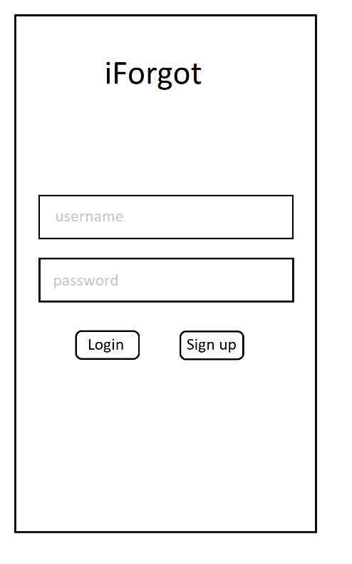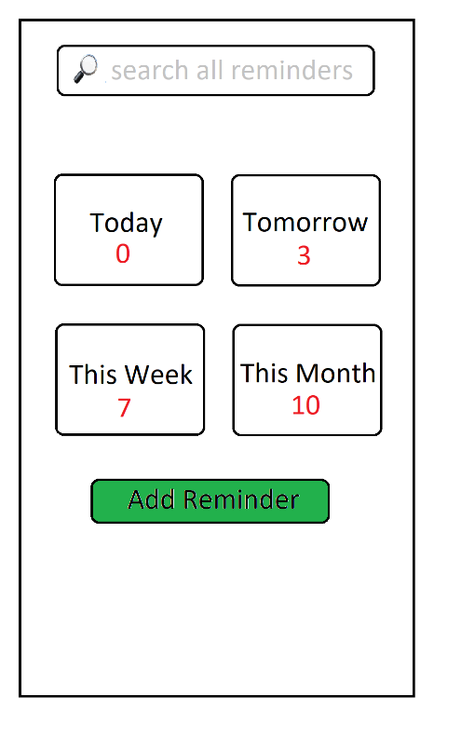

Figure 1: Original Basic Layout detailing key information

These wireframes were made as a guide line to provide context for page design and functionality while coding in javascript and ejs. These wireframes have now been replaced with the figma prototype pages.

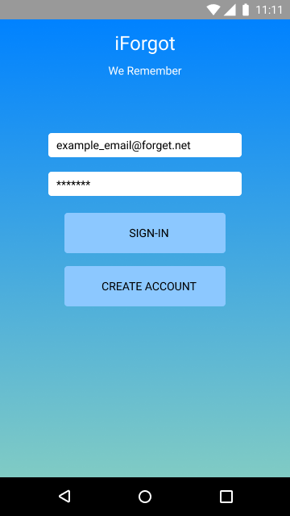 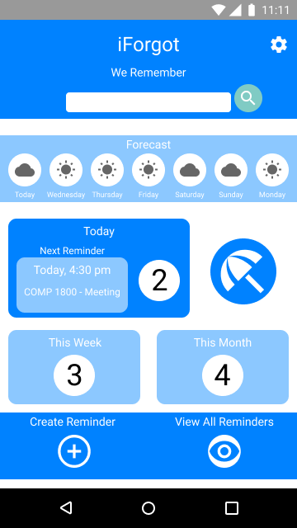 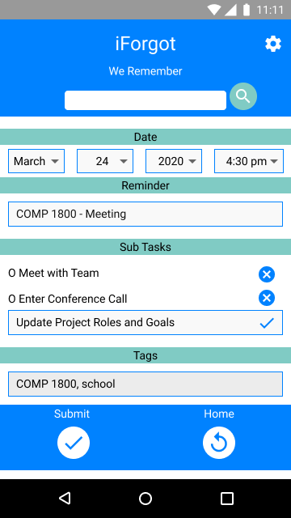

Figure 2: Prototypes for the sign-in, main application, and reminder creation pages.

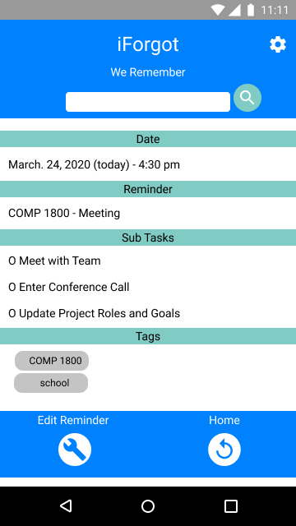 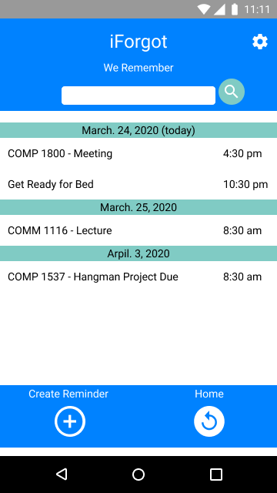 

Figure 3: Prototypes of the individual, total, and monthly reminder pages

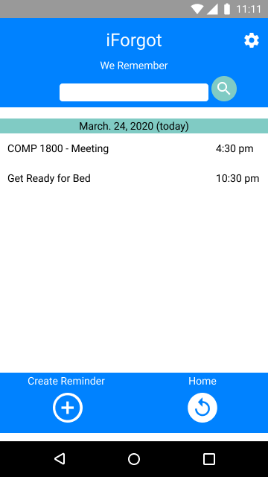 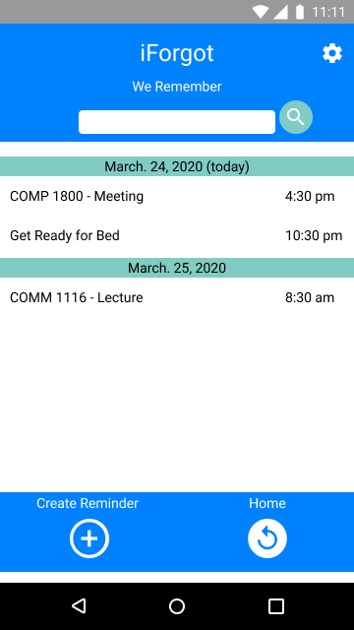

Figure 4: Prototypes for the daily and weekly reminders pages.

These prototypes were also designed in figma and contained interactive links to demonstrate the movement between pages in addition to their overall layout and design. These prototypes were created by Simon Newell.

The next prototype designed was the landing page, which was designed both for desktops and phone screen sizes, unlike the reminders which were based on the phone screen for readability and use.

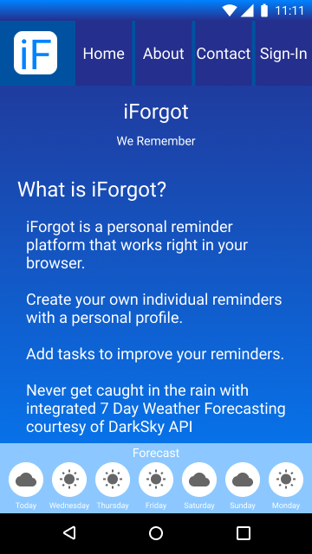

Figure 5: Prototype of the collapsed view of the landing page for phones and small screens.

The prototype landing page, as seen above, also featured use of the forecasting function of the main application, using the current geographical location of the user on page load. Due to difficulty mocking the server and subsequently fetching weather data this feature was not implemented in the current iteration of the landing page.

Other differences in the design were the removal of the gradient background in favor of single block colours for the colour scheme. This was partly to assist in readability and partly to reduce difficulty in implementation of style using Bootstrap.

The navbar would also be made into a collapsible ‘burger’ button for small screens, rather than reducing the size of individual buttons. Once again this was primarily a consideration of ease of use as well as readability, as shrinking buttons would make them difficult to read.

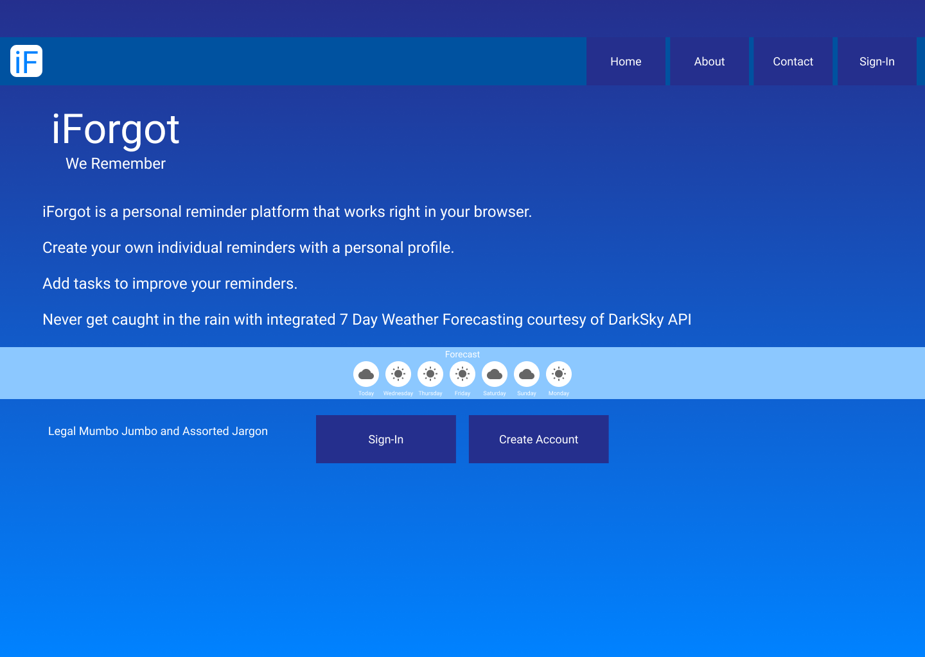

Figure 6: Prototype of the expanded landing page for desktop and larger screens.

The larger landing page showcases the lower buttons. Currently application functionality has account creation and account sign-in both using the common sign in screen. This makes the second ‘Create Account’ button somewhat erroneous, and it may be removed in future iterations.

No pages have been designed for about or contact pages. These would normally link to appropriate (essentially static) pages.

## Current Progress

Currently the landing page, main reminder page, and

# Creating/Editing Reminders

# Reminder Persistence

# Authentication

# Weather Forecasting (Dark Sky API)